Week 07: Text Processing Algorithms

Strings

Strings | 2/64
A string is a sequence of characters.
An alphabet Σ is the set of possible characters in strings.
Examples of strings:
- C program
- HTML document
- DNA sequence
- Digitized image
Examples of alphabets:
- ASCII
- Unicode
- {0,1}
- {A,C,G,T}

... Strings | 3/64
Notation:
- length(P) … #characters in P
- λ … empty string (length(λ) = 0)
- Σ^{m} … set of all strings of length m over alphabet Σ
- Σ* … set of all strings over alphabet Σ
νω denotes the concatenation of strings ν and ω
Note: length(νω) = length(ν)+length(ω) λω = ω = ωλ

... Strings | 4/64
Notation:
- substring of P … any string Q such that P = νQω, for some ν,ω∈Σ*
- prefix of P … any string Q such that P = Qω, for some ω∈Σ*
- suffix of P … any string Q such that P = ωQ, for some ω∈Σ*

Exercise #1: Strings | 5/64
The string a/a of length 3 over the ASCII alphabet has
- how many prefixes?
- how many suffixes?
- how many substrings?

- 4 prefixes: "" "a" "a/" "a/a"
- 4 suffixes: "a/a" "/a" "a" ""
- 6 substrings: "" "a" "/" "a/" "/a" "a/a"
Note:
"" means the same as λ (= empty string)

... Strings | 7/64
ASCII (American Standard Code for Information Interchange)
- Specifies mapping of 128 characters to integers 0..127
- The characters encoded include:
  - upper and lower case English letters: A-Z and a-z
  - digits: 0-9
  - common punctuation symbols
  - special non-printing characters: e.g. newline and space
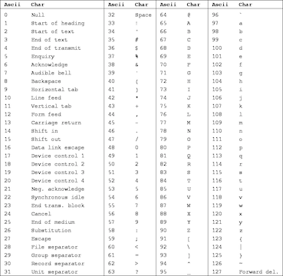

... Strings | 8/64
Reminder:
In C a string is an array of chars containing ASCII codes
- these arrays have an extra element containing a 0
- the extra 0 can also be written '\0' (null character or null-terminator)
- convenient because don't have to track the length of the string
Because strings are so common, C provides convenient syntax:
char str[] = "hello";
Note: str[] will have 6 elements

... Strings | 9/64
C provides a number of string manipulation functions via #include <string.h>, e.g.
strlen()
strncpy()
strncat()
strstr()
Example:
char *strncat(char *dest, char *src, int n)
- appends string src to the end of dest overwriting the '\0' at the end of dest and adds terminating '\0'
- returns start of string dest
- will never add more than n characters
(If src is less than n characters long, the remainder of dest is filled with '\0' characters. Otherwise, dest is not null-terminated.)

Pattern Matching

Pattern Matching | 11/64
Example (pattern checked backwards):
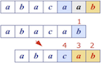
- Text … abacaab
- Pattern … abacab

... Pattern Matching | 12/64
Given two strings T (text) and P (pattern),
the pattern matching problem consists of finding a substring of T equal to P
Applications:
- Text editors
- Search engines
- Biological research

... Pattern Matching | 13/64
Brute-force pattern matching algorithm
- checks for each possible shift of P relative to T
  - untile a match is found, or
  - all placements of the pattern have been tried
BruteForceMatch(T,P):
| Input text T of length n, pattern P of length m
| Output starting index of a substring of T equal to P
| -1 if no such substring exists
|
| for all i=0..n-m do
| | j=0
| | while j<m ∧ T[i+j]=P[j] do
| | j=j+1
| | if j=m then
| | return i
| | end if
| | end while
| end for
| return -1

Analysis of Brute-force Pattern Matching | 14/64
Brute-force pattern matching runs in O(n·m)
Examples of worst case (forward checking):
- T = aaa…ah
- P = aaah
- may occur in DNA sequences
- unlikely in English text

Boyer-Moore Algorithm | 15/64
The Boyer-Moore pattern matching algorithm is based on two heuristics:
- Looking-glass heuristic: Compare P with subsequence of T moving backwards
- Character-jump heuristic: When a mismatch occurs at T[i]=c
  - if P contains c ⇒ shift P so as to align the last occurrence of c in P with T[i]
  - otherwise ⇒ shift P so as to align P[0] with T[i+1] (a.k.a. "big jump")

... Boyer-Moore Algorithm | 16/64
Example:
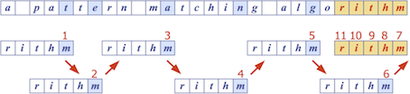

... Boyer-Moore Algorithm | 17/64
Boyer-Moore algorithm preprocesses pattern P and alphabet Σ to build
- last-occurrence function L
  - L maps Σ to integers such that L(c) is defined as
    - the largest index i such that P[i]=c, or
    - -1 if no such index exists
Example: Σ = {a,b,c,d}, P = acab
c | a | b | c | d
L(c) | 2 | 3 | 1 | -1
- L can be represented by an array indexed by the numeric codes of the characters
- L can be computed in O(m+s) time (m … length of pattern, s … size of Σ)

... Boyer-Moore Algorithm | 18/64
BoyerMooreMatch(T,P,Σ):
| Input text T of length n, pattern P of length m, alphabet Σ
| Output starting index of a substring of T equal to P
| -1 if no such substring exists
|
| L=lastOccurenceFunction(P,Σ)
| i=m-1, j=m-1
| repeat
| | if T[i]=P[j] then
| | if j=0 then
| | return i
| | else
| | i=i-1, j=j-1
| | end if
| | else
| | i=i+m-min(j,1+L[T[i]])
| | j=m-1
| | end if
| until i≥n
| return -1
- Biggest jump (m characters ahead) occurs when L[T[i]] = -1

... Boyer-Moore Algorithm | 19/64
Case 1: j ≤ 1+L[c]
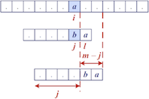
Case 2: 1+L[c] < j
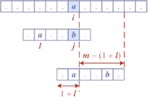

Exercise #2: Boyer-Moore algorithm | 20/64
For the alphabet Σ = {a,b,c,d}
- compute last-occurrence function L for pattern P = abacab
- trace Boyer-More on P and text T = abacaabadcabacabaabb
  - how many comparisons are needed?

c | a | b | c | d
L(c) | 4 | 5 | 3 | -1

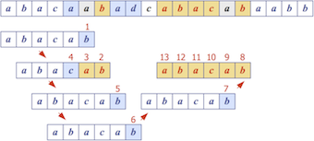
13 comparisons in total

... Boyer-Moore Algorithm | 22/64
Analysis of Boyer-Moore algorithm:
- Runs in O(nm+s) time
  - m … length of pattern n … length of text s … size of alphabet
- Example of worst case:
  - T = aaa … a
  - P = baaa
- Worst case may occur in images and DNA sequences but unlikely in English texts
⇒ Boyer-Moore significantly faster than brute-force on English text

Knuth-Morris-Pratt Algorithm | 23/64
The Knuth-Morris-Pratt algorithm …
- compares the pattern to the text left-to-right
- but shifts the pattern more intelligently than the brute-force algorithm
Reminder:
- Q is a prefix of P … P = Qω, for some ω∈Σ*
- Q is a suffix of P … P = ωQ, for some ω∈Σ*

... Knuth-Morris-Pratt Algorithm | 24/64
When a mismatch occurs …
- what is the most we can shift the pattern to avoid redundant comparisons?
- Answer: the largest prefix of P[0..j] that is a suffix of P[1..j]

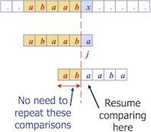

... Knuth-Morris-Pratt Algorithm | 25/64
KMP preprocesses the pattern to find matches of its prefixes with itself
- Failure function F(j) defined as
  - the size of the largest prefix of P[0..j] that is also a suffix of P[1..j]
- if mismatch occurs at P_{j} ⇒ advance j to F(j-1)
Example: P = abaaba
j | 0 | 1 | 2 | 3 | 4 | 5
P_{j} | a | b | a | a | b | a
F(j) | 0 | 0 | 1 | 1 | 2 | 3
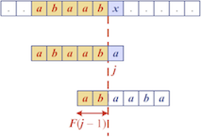

... Knuth-Morris-Pratt Algorithm | 26/64
KMPMatch(T,P):
| Input text T of length n, pattern P of length m
| Output starting index of a substring of T equal to P
| -1 if no such substring exists
|
| F=failureFunction(P)
| i=0, j=0
| while i<n do
| | if T[i]=P[j] then
| | if j=m-1 then
| | return i-j
| | else
| | i=i+1, j=j+1
| | end if
| | else
| | if j>0 then
| | j=F[j-1]
| | else
| | i=i+1
| | end if
| | end if
| end while
| return -1

Exercise #3: KMP-Algorithm | 27/64
- compute failure function F for pattern P = abacab
- trace Knuth-Morris-Pratt on P and text T = abacaabadcabacabaabb
  - how many comparisons are needed?

j | 0 | 1 | 2 | 3 | 4 | 5
P_{j} | a | b | a | c | a | b
F(j) | 0 | 0 | 1 | 0 | 1 | 2

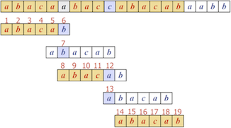
19 comparisons in total

... Knuth-Morris-Pratt Algorithm | 29/64
Construction of the failure function is similar to the KMP algorithm itself:
failureFunction(P):
| Input pattern P of length m
| Output failure function for P
|
| F[0]=0
| i=1, j=0
| while i<m do
| | if P[i]=P[j] then
| | F[i]=j+1
| | i=i+1, j=j+1
| | else if j>0 then
| | j=F[j-1]
| | else
| | F[i]=0
| | i=i+1
| | end if
| end while
| return F

... Knuth-Morris-Pratt Algorithm | 30/64
Analysis of failure function computation:
- At each iteration of the while-loop, either
  - i increases by one, or
  - the "shift amount" i-j increases by at least one (observe that F(j-1)<j)
- Hence, there are no more than 2·m iterations of the while-loop
⇒ failure function can be computed in O(m) time

... Knuth-Morris-Pratt Algorithm | 31/64
Analysis of Knuth-Morris-Pratt algorithm:
- Failure function can be computed in O(m) time
- At each iteration of the while-loop, either
  - i increases by one, or
  - the "shift amount" i-j increases by at least one (observe that F(j-1)<j)
- Hence, there are no more than 2·n iterations of the while-loop
⇒ KMP's algorithm runs in optimal time O(m+n)

Boyer-Moore vs KMP | 32/64
Boyer-Moore algorithm
- decides how far to jump ahead based on the mismatched character in the text
- works best on large alphabets and natural language texts (e.g. English)
Knuth-Morris-Pratt algorithm
- uses information embodied in the pattern to determine where the next match could begin
- works best on small alphabets (e.g. A,C,G,T)

Tries

Preprocessing Strings | 34/64
Preprocessing the pattern speeds up pattern matching queries
- After preprocessing P, KMP algorithm performs pattern matching in time proportional to the text length
If the text is large, immutable and searched for often (e.g., works by Shakespeare)
- we can preprocess the text instead of the pattern

... Preprocessing Strings | 35/64
A trie …
- is a compact data structure for representing a set of strings
  - e.g. all the words in a text, a dictionary etc.
- supports pattern matching queries in time proportional to the pattern size
Note: Trie comes from retrieval, but is pronounced like "try" to distinguish it from "tree"

Tries | 36/64
Tries are trees organised using parts of keys (rather than whole keys)
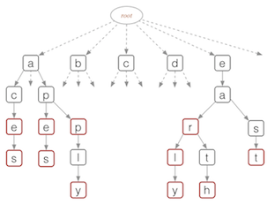

... Tries | 37/64
Each node in a trie …
- contains one part of a key (typically one character)
- may have up to 26 children
- may be tagged as a "finishing" node
- but even "finishing" nodes may have children
Depth d of trie = length of longest key value
Cost of searching O(d) (independent of n)

... Tries | 38/64
Possible trie representation:
#define ALPHABET_SIZE 26

typedef struct Node *Trie;

typedef struct Node {
bool finish;
Item data;
Trie child[ALPHABET_SIZE];
} Node;

typedef char *Key;

... Tries | 39/64
Note: Can also use BST-like nodes for more space-efficient implementation of tries
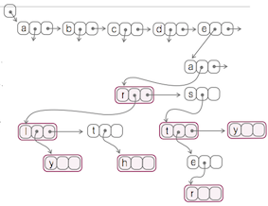

Trie Operations | 40/64
Basic operations on tries:
- search for a key
- insert a key

Trie Operations | 41/64
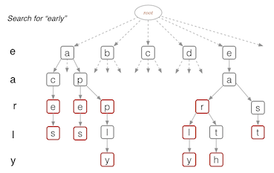

... Trie Operations | 42/64
Traversing a path, using char-by-char from Key:
find(trie,key):
| Input trie, key
| Output pointer to element in trie if key found
| NULL otherwise
|
| node=trie
| for each char in key do
| | if node.child[char] exists then
| | node=node.child[char]
| | else
| | return NULL
| | end if
| end for
| if node.finish then
| return node
| else
| return NULL
| end if

... Trie Operations | 43/64
Insertion into Trie:
insert(trie,item,key):
| Input trie, item with key of length m
| Output trie with item inserted
|
| if trie is empty then
| t=new trie node
| end if
| if m=0 then
| t.finish=true, t.data=item
| else
| t.child[key[0]]=insert(trie,item,key[1..m-1])
| end if
| return t

... Trie Operations | 44/64
Analysis of standard tries:
- O(n) space
- insertion and search in time O(d·m)
  - n … total size of text (e.g. sum of lengths of all strings in a given dictionary)
  - m … size of the string parameter of the operation (the "key")
  - d … size of the underlying alphabet (e.g. 26)

Word Matching With Tries

Word Matching with Tries | 46/64
Preprocessing the text:
- Insert all searchable words of a text into a trie
- Each leaf stores the occurrence(s) of the associated word in the text

... Word Matching with Tries | 47/64
Example text and corresponding trie of searchable words:
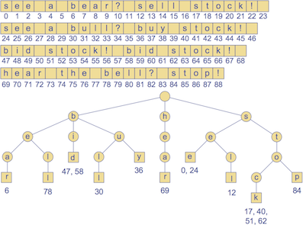

Compressed Tries | 48/64
Compressed tries …
- have internal nodes of degree ≥ 2
- are obtained from standard tries by compressing "redundant" chains of nodes
Example:
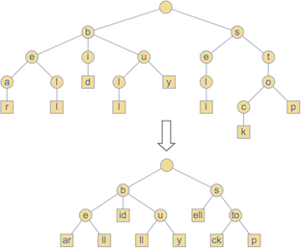

... Compressed Tries | 49/64
Possible compact representation of a compressed trie to encode an array S of strings:
- nodes store ranges of indices instead of substrings
  - use triple (i,j,k) to represente substring S[i][j..k]
- requires O(s) space (s = #strings in array S)
Example:
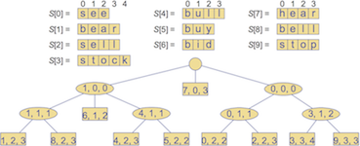

Pattern Matching With Suffix Tries | 50/64
The suffix trie of a text T is the compressed trie of all the suffixes of T
Example:
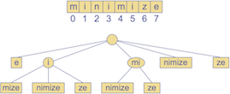

... Pattern Matching With Suffix Tries | 51/64
Compact representation:
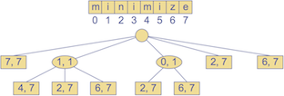

... Pattern Matching With Suffix Tries | 52/64
Input:
- compact suffix trie for text T
- pattern P
Goal:
- find starting index of a substring of T equal to P

... Pattern Matching With Suffix Tries | 53/64
Analysis of pattern matching using suffix tries:
Suffix trie for a text of size n …
- can be constructed in O(n) time
- uses O(n) space
- supports pattern matching queries in O(s·m) time
  - m … length of the pattern
  - s … size of the alphabet

Text Compression

Text Compression | 55/64
Problem: Efficiently encode a given string X by a smaller string Y
Applications:
- Save memory and/or bandwidth
Huffman's algorithm
- computes frequency f(c) for each character c
- encodes high-frequency characters with short code
- no code word is a prefix of another code word
- uses optimal encoding tree to determine the code words

... Text Compression | 56/64
Code … mapping of each character to a binary code word
Prefix code … binary code such that no code word is prefix of another code word
Encoding tree …
- represents a prefix code
- each leaf stores a character
- code word given by the path from the root to the leaf (0 for left child, 1 for right child)

... Text Compression | 57/64
Example:
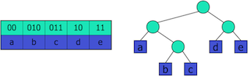

... Text Compression | 58/64
Text compression problem
Given a text T, find a prefix code that yields the shortest encoding of T
- short codewords for frequent characters
- long code words for rare characters

... Text Compression | 59/64
Example: T = abracadabra
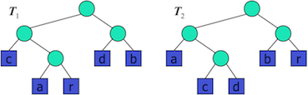
T₁ requires 29 bits to encode text T,
T₂ requires 24 bits

... Text Compression | 60/64
Huffman's algorithm
- computes frequency f(c) for each character
- successively combines pairs of lowest-frequency characters to build encoding tree "bottom-up"
Example: abracadabra
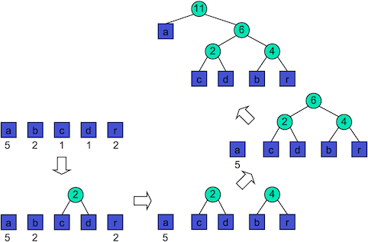

Huffman Code | 61/64
Huffman's algorithm using priority queue:
HuffmanCode(T):
| Input string T of size n
| Output optimal encoding tree for T
|
| compute frequency array
| Q=new priority queue
| for all characters c do
| T=new single-node tree storing c
| join(Q,T) with frequency(c) as key
| end for
| while |Q|≥2 do
| f₁=Q.minKey(), T₁=leave(Q)
| f₂=Q.minKey(), T₂=leave(Q)
| T=new tree node with subtrees T₁ and T₂
| join(Q,T) with f₁+f₂ as key
| end while
| return leave(Q)

... Huffman Code | 62/64
Larger example: a fast runner need never be afraid of the dark
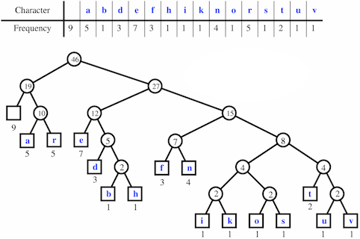

... Huffman Code | 63/64
Analysis of Huffman's algorithm:
- O(n+d·log d) time
  - n … length of the input text T
  - s … number of distinct characters in T

Summary | 64/64
- Alphabets and words
- Pattern matching
  - Boyer-Moore, Knuth-Morris-Pratt
- Tries
- Text compression
  - Huffman code

- Suggested reading:
  - Tries … Sedgewick, Ch.15.2

Produced: 23 Jan 2018

